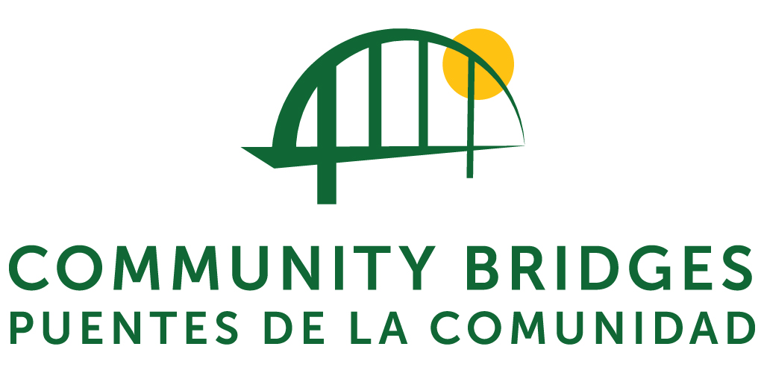

Media Contact: Lois Sones, Elderday Program Director, 831-458-3481 x4010, loiss@cbridges.org

FOR IMMEDIATE RELEASE: Tuesday, March 9, 2015

Elderday Adult Day Health, a program of Community Bridges, hosts its first Open House

Elderday Adult Day Health, a program of Community Bridges, is hosting its first Open House on Friday, March 9 from 4:00 to 6:00pm.

Get an exclusive view of Elderday’s new public service announcement video about Santa Cruz County’s aging population, participate in a raffle to support program activities, and view artwork created by participants.

Appetizers will be served.

Elderday is located at 100 Pioneer Street, Suite C, in Santa Cruz. This event is open to the public.

About Elderday Adult Day Health, a program of Community Bridges
Elderday Adult Day Health, a program of Community Bridges, empowers older adults in Santa Cruz County to live with greater independence and dignity.

Since the significant changes were made to NF-A in Title 22 of the California Code of Regulations in 2012, one-third of all Community-Based Adult Services (CBAS) programs in California have closed. Elderday is the only one in the Santa Cruz County area that remains.

Each year, Elderday serves 170 of Santa Cruz County’s frailest adults and elders with complex medical, psychological, and cognitive impairments. Each day of hospitalization prevented by Elderday saves the public approximately $2,630 per participant.

